**AWS Advanced Projects (Day15 – Day16)**

**=============================================**

**Working with Lambda:**

Step1: Create two s3 buckets with the name

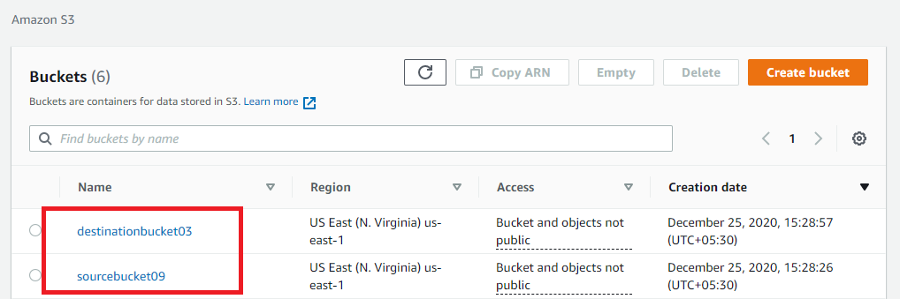

Fig.1 S3 console

Step2: Create a policy with limited Read-write permissions using a JSON script

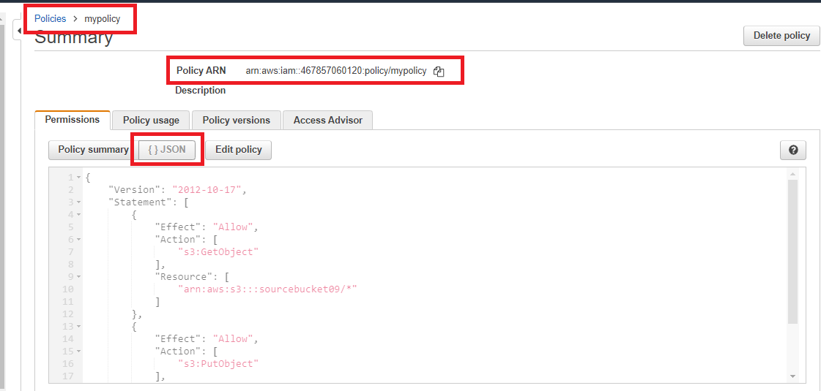

Fig.2 Json script

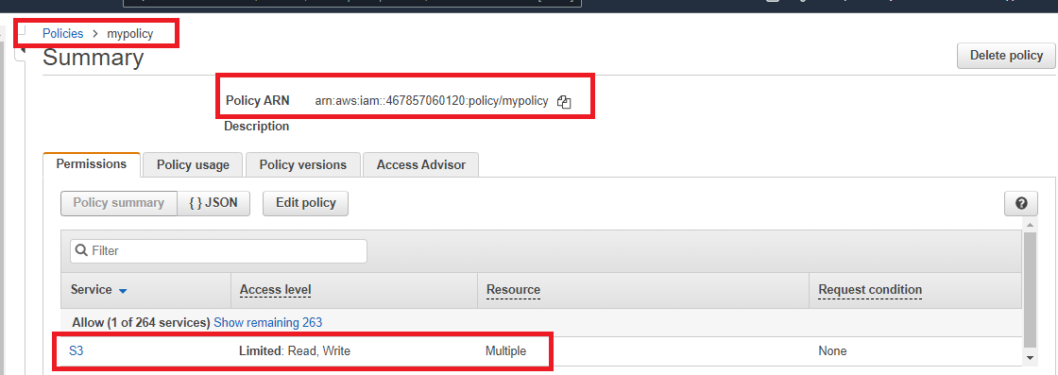

Fig.3 Policy console

Step3: Create a role and attach the policy that was created in the previous step.

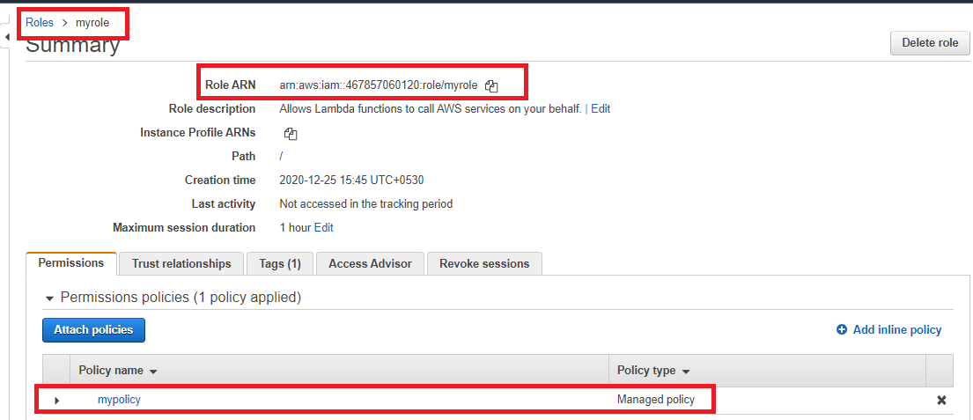

Fig.4 Role console

Step4: Create a Lambda function

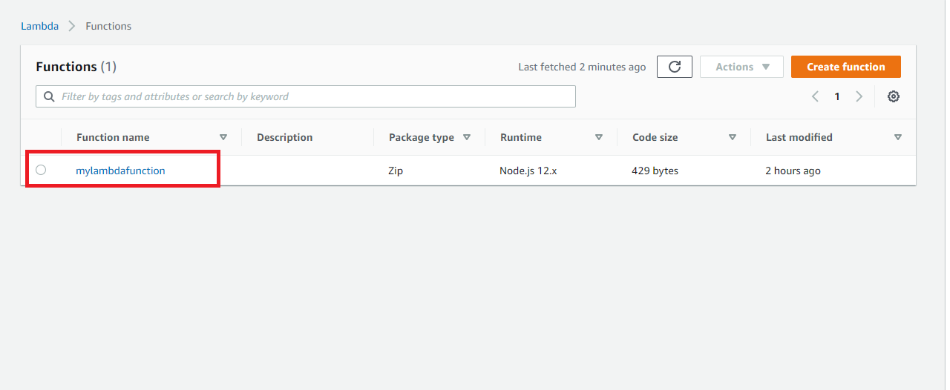

Fig.5 Lambda dashboard

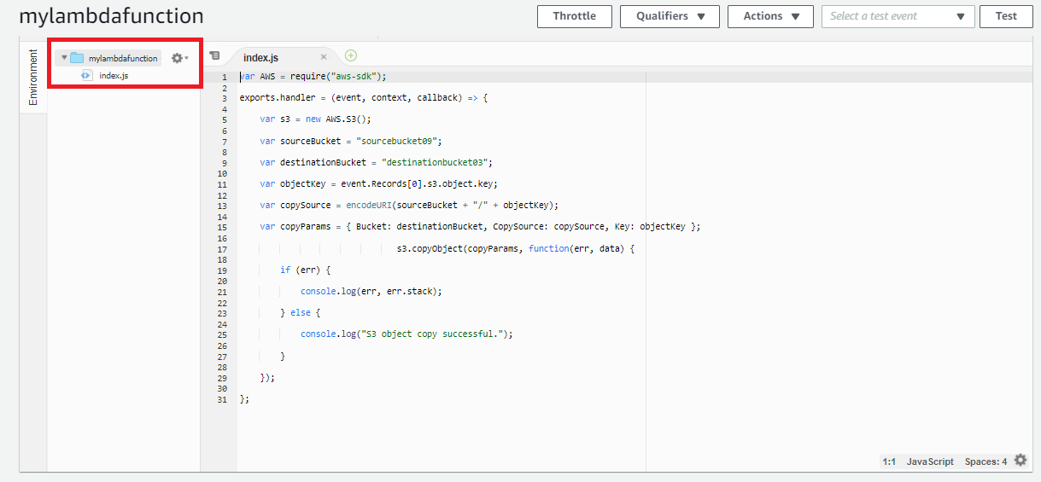

Fig.6 js file edited

Step5: Adding triggers to the lambda function

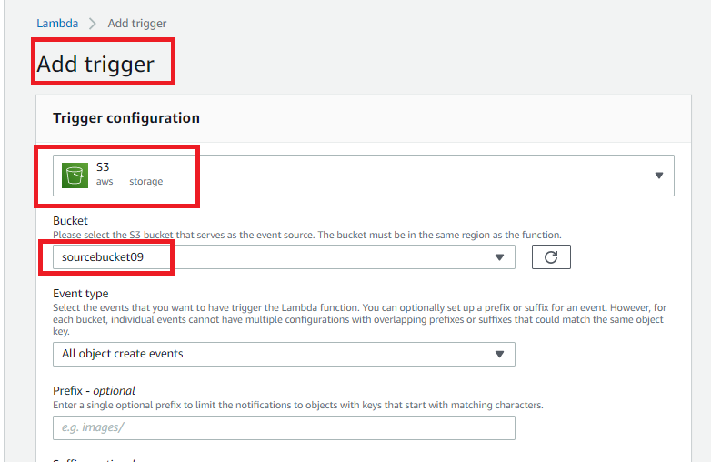

Fig.7 Adding trigger

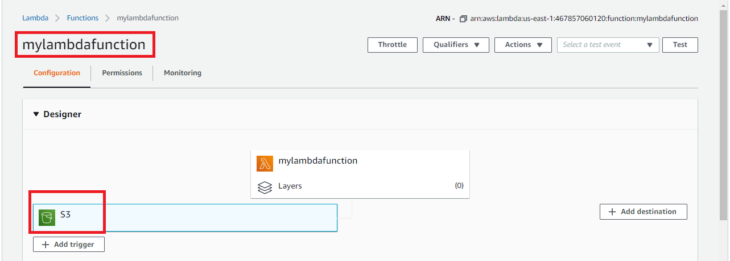

Fig.8 lambda configuration page with trigger added

Step 6: Test by uploading objects into the source bucket

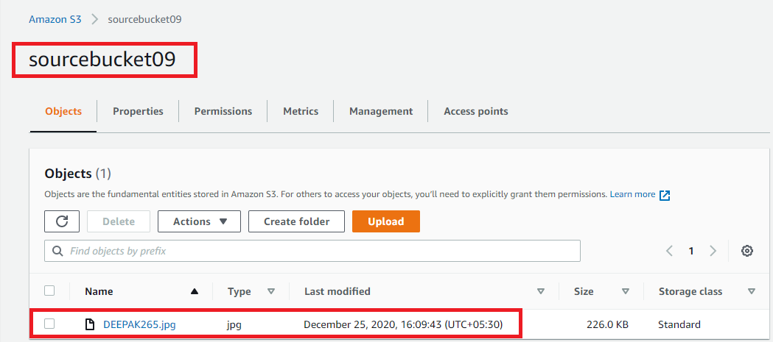

Fig. 9 object uploaded in the source bucket

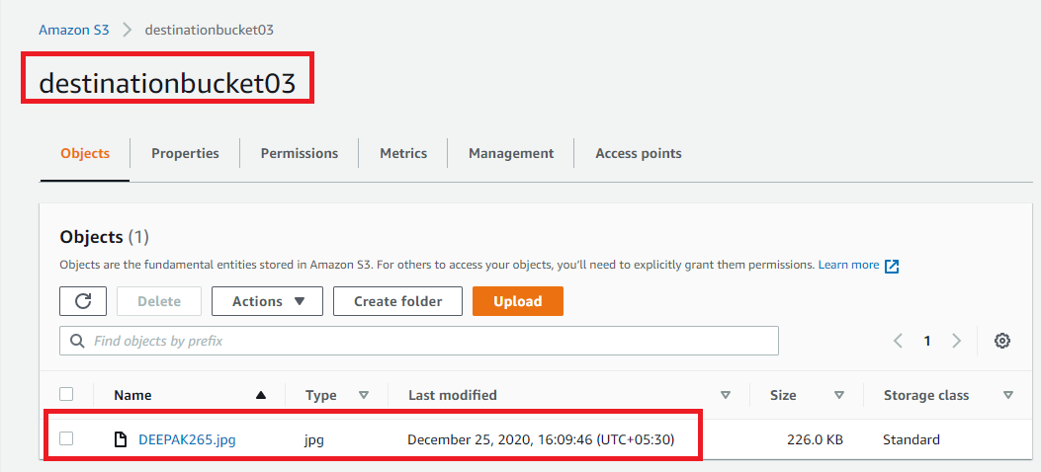

Fig. 10 object replicated in the destination bucket.

=============================================================

**Working with Elastic container service using fargate:**

Step1: Getting started with amazon ECS using fargate

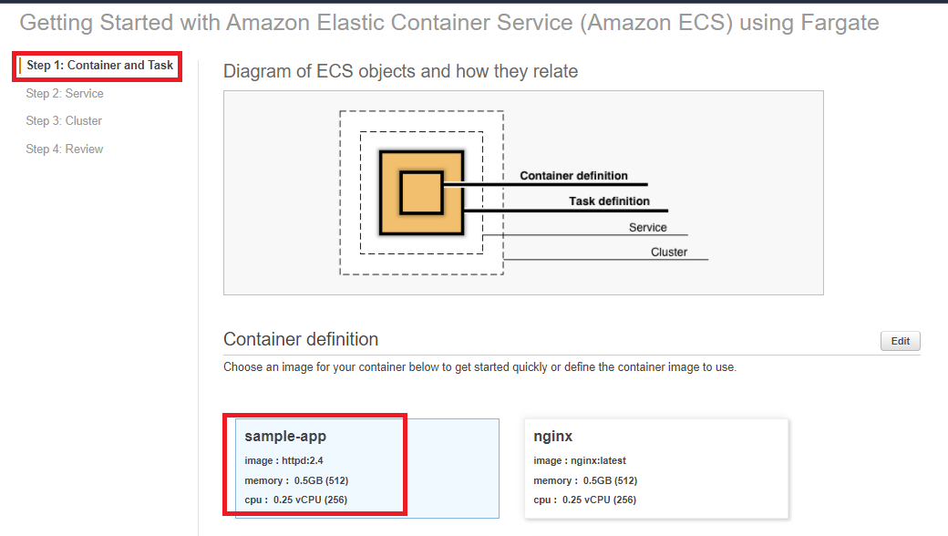

Fig. 1 ECS console

Step2: Creating container and task definition

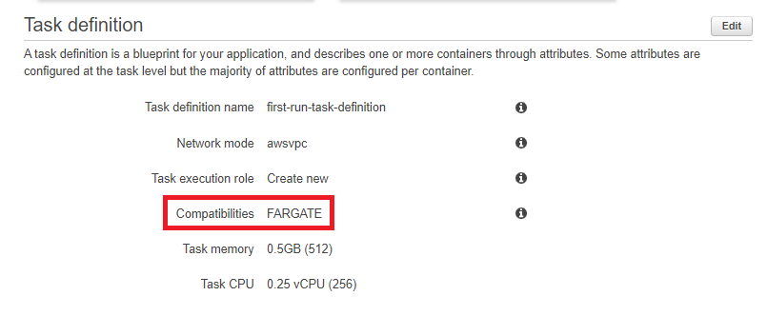

Fig. 2 Task definition

Step3: Configuring the service

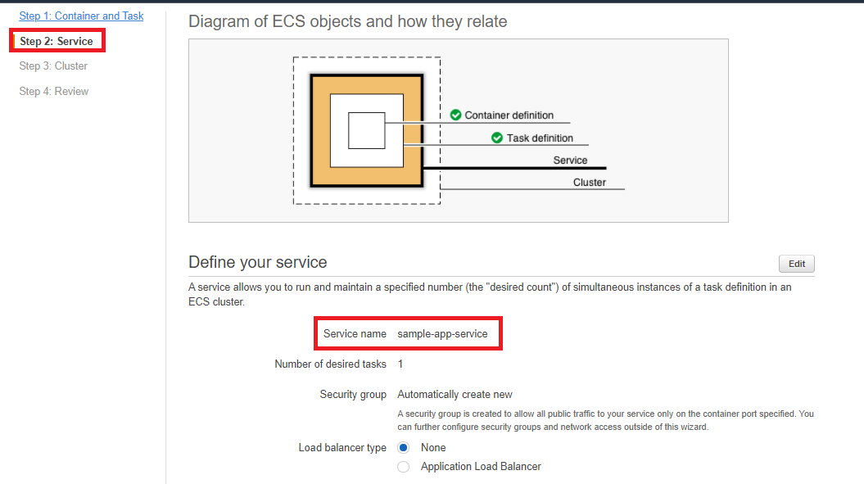

Fig. 3 service panel

Step4: Configuring the cluster

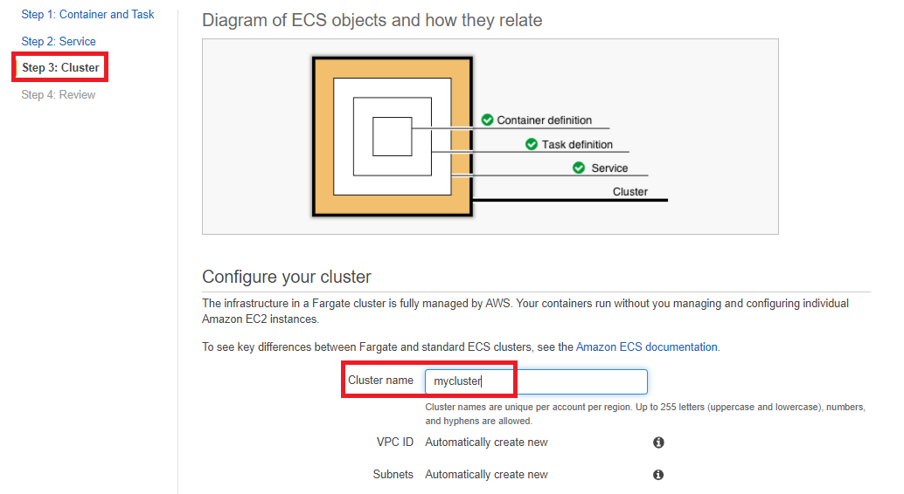

Fig. 4 cluster panel

Step5: viewing the service

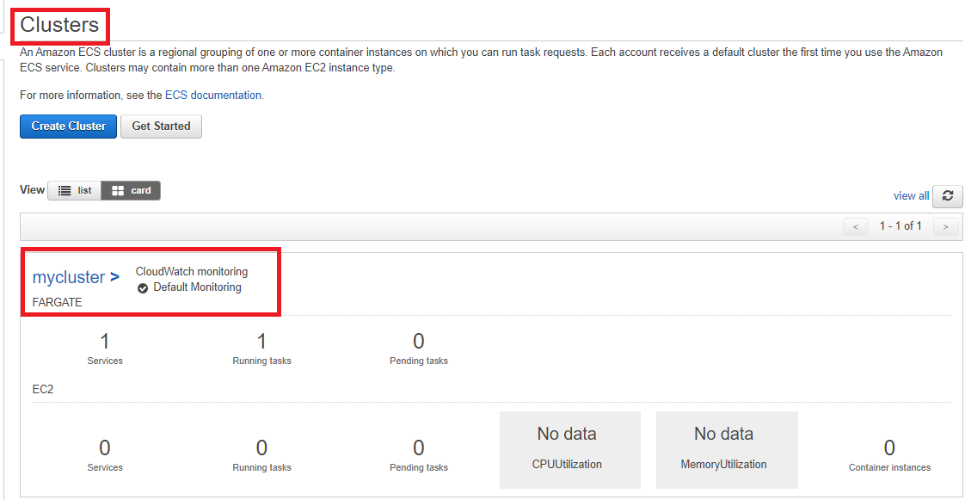

Fig. 5.1 Cluster Dashboard

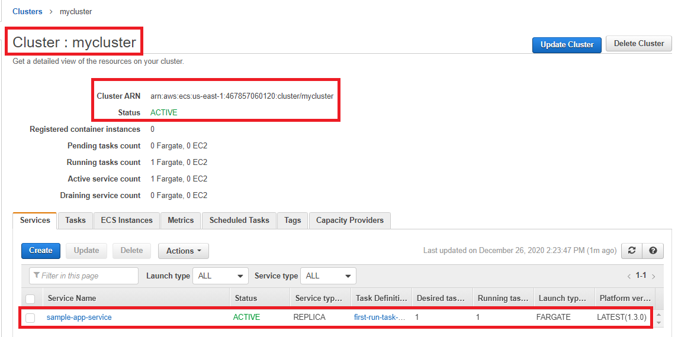

Fig. 5.2 Cluster Information

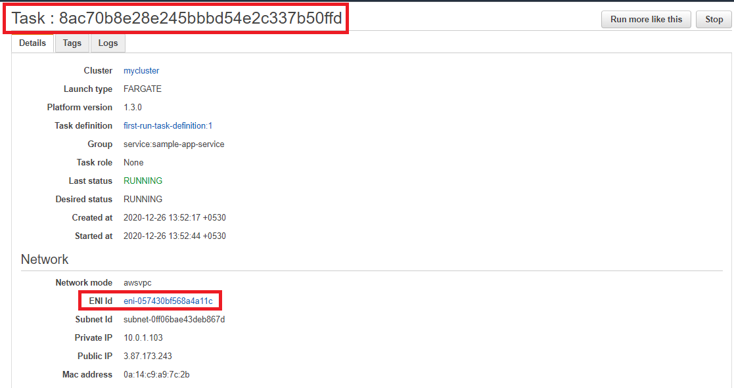

Fig. 5.3 panel displaying ENI ID

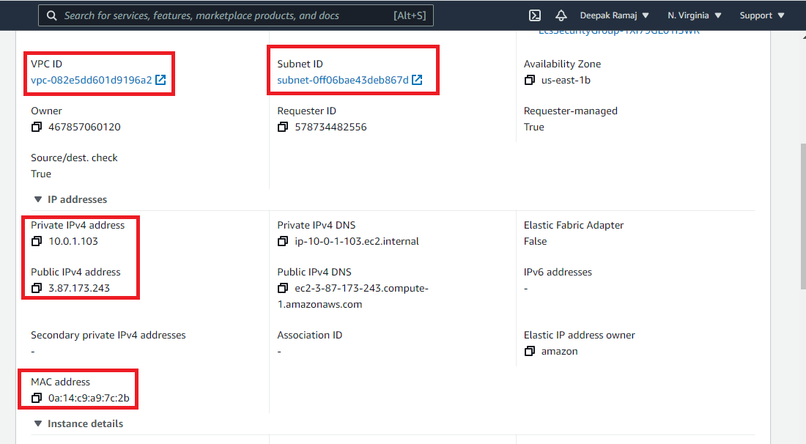

Fig. 5.4 Panel displaying the private, public, and the macid

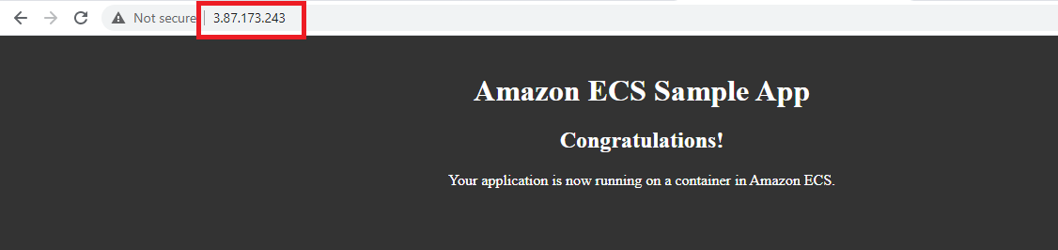

Fig. 5.5 Display application